**Story: Student can register an account. (Iteration 1)**

Tasks: Write user documentation for registering an account.

As a primary user of the application, students can register their account. This is the first and foremost tasks for student’s user to use the application. In order to complete the registration process students will be asked to provide their basic information which includes both required and optional fields. Below are the list of information that the student should consider:

Student First and Last (required) Student Number (required)  
Student Program (required) Email (required)  
Address (required) Phone/Cell  
Password selection (required) Password confirmation (required)  
Company Position/job title  
Term Company Address  
Advisor Name

To access the registration page, navigate to the home page (insert web address) and select registration tab (see figure 1). As soon as you hit the registration tab the system will give option to enter your account registration information (see figure 2). Registered students can directly entered their username (student ID) and password, and identify themselves as student from the dropdown menu and hit the login button.

*Figure 1: CoopReporting application login/home page*

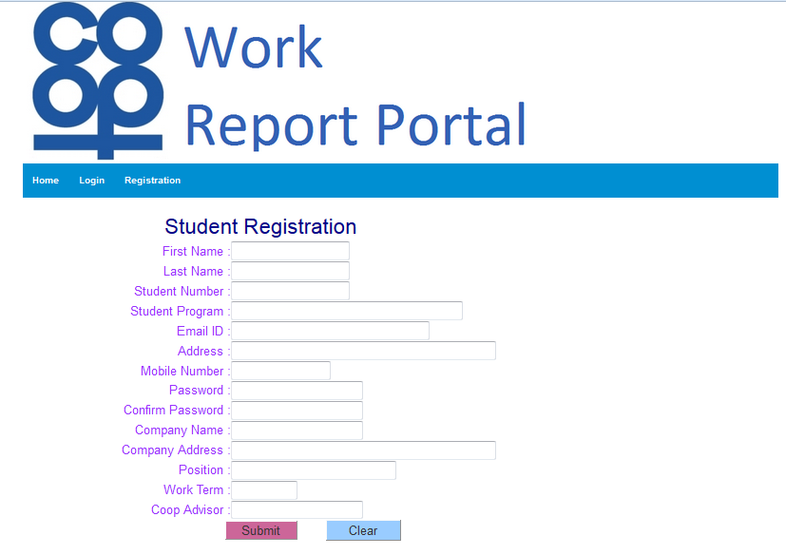Once you entered the registration info such as first name, last name, student number, email ID etc. (see figure 2) and hit submit button, the system will display registration message. Moreover, if the registration information pass the validation and the system will display the registration message dialog also, where student will be given option review and edit the information they entered in registration process.

*Figure 1: CoopReporting application student registration page*

Student also have options to clear the inputs of registration if they wish to reenter the information, but the registration is mandatory to use the application/system. Finally, student can close the registration message by clicking done button at the bottom of the page or close the page.